

***IIeP - Italian Interoperable eProcurement***

**D3.1**

**eProcurement platform analysis, guideline & design document**

|  |  |
| --- | --- |
| **Project number** | INEA/CEF/ICT/A2016/1170516  2016-IT-IA-0038 |
| **Project acronym** | ESPD |
| **Project title** | ESPD Interoperability and Diffusion |
| **Project duration** | 13 months (01/03/2017 – 31/03/2018) |
| **Programme** | Connecting Europe Facility (CEF) |
|  |  |
| **Activity title** | eProcurement Platform upgrade |
| **Deliverable number** | D3.1 |
| **Version (date)** | 0.0.1 (31/07/2017) |
| **Due date** | 30/06/2017 |
|  |  |
| **Responsible organisation** | Intercent-ER |
| **Editor** | Intercent-ER |
|  |  |
| **Abstract** | This deliverable provides functional and technical details related to the implementation of the ESPD in the eProcurement platform run by Intercent-ER (SATER - *Sistema Acquisti Telematici Emilia-Romagna*). The target model is designed to allow the end user to create an ESPD request compliant with the ESPD standard form regulated by the European Commission, pre-fill the ESPD response with data stored in the platform and download or upload an ESPD request / response |
| **Keywords** | Gap Analysis, selection criteria, exclusion grounds, ESPD request, ESPD response, strict / national criteria |

**Editor**

Intercent-ER

**Reviewers**

Intercent-ER

**Contributors**

AgiD

**Acknowledgement**

This work was partially supported by the European Commission (EC) through the Connecting Europe Facility (CEF) programme under project ESPD (grant agreement no. INEA/CEF/ICT/A2016/1170516).

**Disclaimer**

The sole responsibility of this publication lies with the author. The European Union is not responsible for any use that may be made of the information contained therein.

**Confidentiality**

The information in this document is confidential and restricted only to the members of the IIeP consortium (including the Commission Services).

**Change Log**

|  |  |  |  |  |
| --- | --- | --- | --- | --- |
| **Version** | **Date** | **Author** | **Organisation** | **Description** |
| 0.0.1 | 27/07/2017 | - | Intercent-ER | First release |
|  |  |  |  |  |
|  |  |  |  |  |
|  |  |  |  |  |
|  |  |  |  |  |

# Table of contents

Table of contents 4

List of tables 4

List of figures 4

Glossary 5

1 Executive summary 6

2 Normative references and EU online services 7

3 Introduction 8

3.1 The general context 8

3.2 ESPD artifact and EDM version chosen for this project 9

4 Global integration scenario and technical components 11

5 Gap analysis 14

6 Data Model Design 17

7 Integration Services Design 18

# List of tables

Table 1 Tender process steps - Gap analysis 16

# List of figures

Figure 1 Public procurement complete process 8

Figure 2 Classification of ESPD requirements 9

Figure 3 Focus on the components to be developed in SATER 12

Figure 4 Sequence diagram of the new tender process, with focus on ESPD 13

# Glossary

|  |  |
| --- | --- |
| **ACK** | Acknowledged. Positive reply obtained after invoking web-services provided by SIMOG to check submitted ESPD criteria for compliancy |
| **A.N.AC.** | *Autorità Nazionale Anti-Corruzione* (National Anti-Corruption Authority) |
| **CA** | Contracting Authority |
| **CEF** | Connecting Europe Facility |
| **CEN** | European Committee for Standardization |
| **CIG** | *Codice Identificativo Gara* (Contract Reference Number): code adopted in Italy to identify a public contract entered into after a tender or entrusted with one of the other methods permitted by the Public Contracts Code |
| **CPB** | Central Purchasing Body |
| **EDM** | Exchange Data Model |
| **EC** | European Commission |
| **EO** | Economic Operator |
| **ESPD** | Electronic Single Procurement Document |
| **EU** | European Union |
| **e-Certis** | Online mapping tool used to identify and compare certificates requested in public procurement procedures across the EU. Available at the following link: *https://ec.europa.eu/growth/tools-databases/ecertis/* |
| **GURI** | Official Journal of the Italian Republic (*Gazzetta Ufficiale della Repubblica Italiana*) |
| **MIT** | Ministry for Infrastructures and Transports (*Ministero delle Infrastrutture e dei Trasporti*) |
| **MS** | Member State |
| **NACK** | Not Acknowledged. Negative reply obtained after invoking web-services provided by SIMOG to check submitted ESPD criteria for compliancy |
| **PA** | Public Administration |
| **PEPPOL** | Pan-European Public Procurement Online |
| **SIMOG** | *Sistema Informativo Monitoraggio Gare* (Tender Monitoring Information System): online national system that allows Contracting Authorities (CAs) to request the Contract Reference Number (CIG) required for economic operators to pay the contribution to the Authority due for participation in public tenders |
| **SME** | Small-Medium Enterprise |
| **TED** | Tenders Electronic Daily |
| **UC** | Use Case |
| **WS** | Web Service |
| **XML** | eXtensible Markup Language |
|  |  |
|  |  |
|  |  |

# Executive summary

Purpose of this document is to describe the enhancements and new implementations designed to cover the business processes involved in the creation, management and upload / download of the ESPD document (request or response).

The To Be scenario has been built based on the following three foundational layers:

* *Business layer*, dealing with processes, functions and events performed or used by business actors and roles;
* *Application layer*, that is software applications which provide services capable to enable the business layer;
* *The Technology layer*, represented by the hardware and communication infrastructure supporting the Application Layer.

In particular, starting from the analysis of the features required to support the operational tasks of the end users belonging to the CA or EO, we have defined the logical components and dataset of the target model, together with the integration services needed to support the exchange of relevant data with A.N.AC. information system (SIMOG) throughout the overall lifecycle of a public tender.

This project is closely linked to the *IIeP – Italian Interoperable eProcurement* action (2015-IT-IA-0108) co-financed by the European Commission and aiming to leverage the online service of e-Certis to get the selection criteria and exclusion grounds needed to build an ESPD request compliant with the EC ESPD standard form.

Within the operational framework depicted in that action, the eProcurement platform uses specific services made available by SIMOG to retrieve and store strict / national criteria published in e-Certis and transcoded for all EU countries. This way, the completeness, correctness and validity of the selection criteria / exclusion grounds included in a ESPD Request created in SATER can be properly checked.

The expected benefits of the implementation described in this deliverable are many. Firstly, it introduces a guided and standardized way of creating the ESPD request needed for capturing data of the EOs interested in participating in a public tender. Moreover, it simplifies life of businesses – especially SMEs – engaging them in larger number of “at home” and cross borders tenders, by fostering the reuse of ESPD responses previously filled on other eProcurement platforms or through the online eESPD service of the EC.

The present document opens with a general introduction on the most relevant normative and operational references related to project scope (chapter 2).

After an introductory chapter framing the general context of the project (chapter 3), we move the focus to the core sections of the document. In particular:

* Chapter 4 presents the high-level architecture of the integration model, with evidence of the technical components to be added or enhanced and the set of services to be released in order to enable the target scenario. It also includes a sequence diagram of a typical eTendering scenario, where the steps related to the ESPD request creation and validation are represented in a graphical mode, together with the main process phases;
* Chapter 5 describes in detail the main gaps found during the As Is analysis of the existing systems and applications. For each gap, a functional solution is identified, anticipating the technical design of data model and integration services described respectively in chapters 6 and 7.

# Normative references and EU online services

**Normative references**

The following documents, in whole or in part, are normatively referenced in this deliverable and their knowledge is useful to understand the scope and goal of the initiative.

It is important to notice that below mentioned documents are analysed and referenced in their status at the time this deliverable has been prepared (July - August 2017).

* Directives 2014/24/EU and 2014/25/EU of the European Parliament respectively on public procurement and procurement by entities operating in the water, energy, transport and postal services sectors. Both documents introduce the adoption of the ESPD (European Single Procurement Document) as a self-declaration document intended for preliminary evidence in a public procurement procedure, obviating the need to produce a substantial number of certificates or other documents related to exclusion and selection criteria in a public tender.

In particular:

* + Art. 59.6 (2014/24/EU) - European Single Procurement Document

*Member States shall make available and up-to-date in e-Certis a complete list of databases containing relevant information on economic operators which can be consulted by contracting authorities from other Member States. Upon request, Member States shall communicate to other Member States any information related to the databases referred to in this Article*;

Art. 61 (2014/24/EU) - Online repository of certificates (e-Certis)

1. *With a view to facilitating cross-border tendering, Member States shall ensure that the information concerning certificates and other forms of documentary evidence introduced in e-Certis established by the Commission is constantly kept up-to-date;*
2. *Contracting authorities shall have recourse to e-Certis and shall require primarily such types of certificates or forms of documentary evidence that are covered by e-Certis;*
3. *The Commission shall make available all language versions of the ESPD in e-Certis.*

* Commission Implementing Regulation (EU) 2016/7 establishing the standard form for the European Single Procurement Document;
* Guidelines no. 3 of 18 July 2016, issued by the italian Ministry for Infrastructures and Transports (MIT) to support the compilation of the standard form of the ESPD (in italian: DGUE – *Documento di Gara Unico Europeo*). These guidelines provide the contracting authorities and entities with some initial information on the correct use of the ESPD, together with a form adapted to current national public contracts regulation (Legislative Decree no. 50, issued on 18 April 2016).

**EU online services**

* ESPD service provided by the European Commission: <https://ec.europa.eu/tools/espd>;
* ESPD Exchange Data Model (ESPD-EDM – Version 1.0.2): <https://espd.github.io/ESPD-EDM/>;
* e-Certis – European information system that helps to identify different certificates requested in procurement procedures across the EU: <https://ec.europa.eu/growth/tools-databases/ecertis/>.

# Introduction

## The general context

**eProcurement** refers to the use of electronic communications and transaction processing by government institutions and other public sector organisations when buying supplies and services or tendering public works. The eProcurement processes can be separated into two operative phases: the pre-award phase and post-award phase.

Pre-Award: eProcurement process phases occurring before the award of the contract (eNotification, eAccess, eSubmission, eEvaluation, eAwarding).

Post-Award: eProcurement process phases occurring after the award of the contract (eOrdering, eInvoicing, ePayment and final eArchiving).

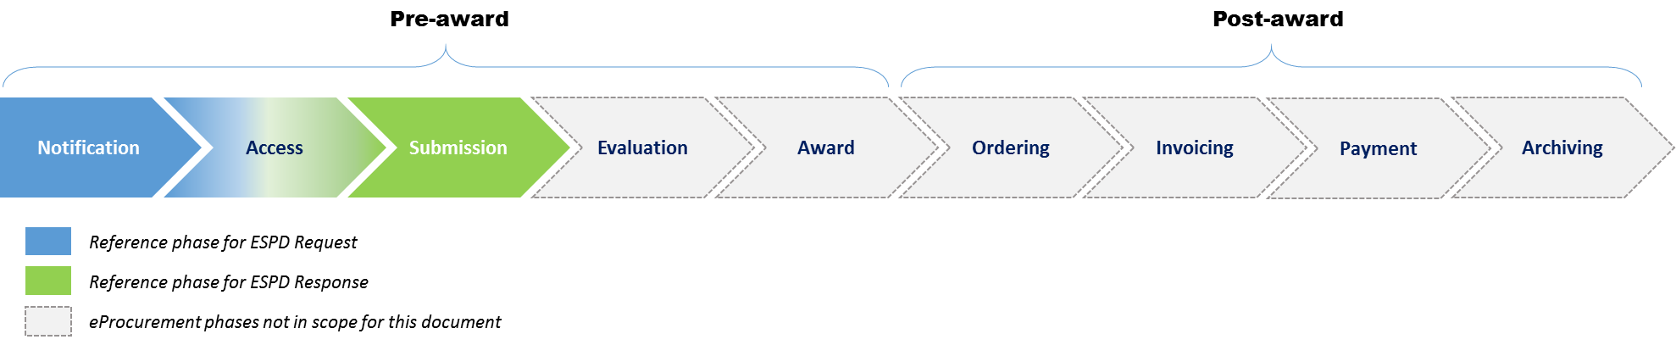

Figure 1 Public procurement complete process

When preparing a new tender procedure - in the early stages of a public procurement process - the CA sets out the selection and exclusion criteria that best suit the requirements of their specific procurement initiative.

These criteria are generally available in e-Certis, the online service promoted and sustained by the European Commission with the aim to support CAs and EOs in identifying the various certificates requested in procurement procedures across the EU. However, as a result of the implementation of the action *IIeP – Italian Interoperable eProcurement* (2015-IT-IA-0108) – the tender monitoring system run by A.N.AC. (SIMOG) will provide the eProcurement platforms with the complete list of criteria retrieved by e-Certis, allowing them to build an ESPD request directly using data stored in their DB.

Please note that not all the requirements are stored and managed in e-Certis. The following schema intends to provide an high-level classification of criteria based on their nature:

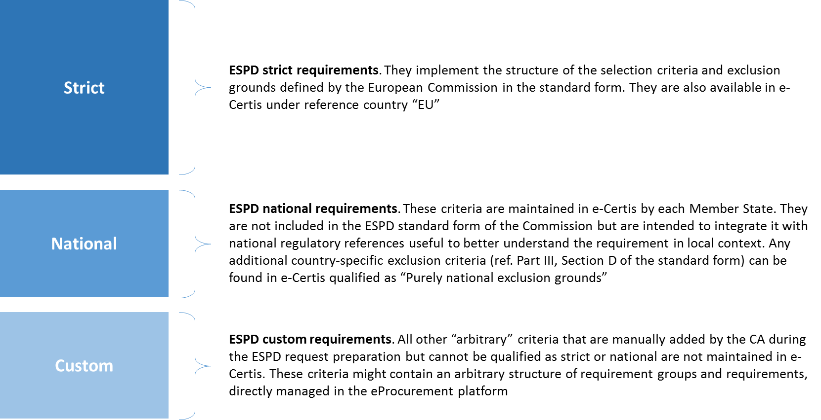

Figure 2 Classification of ESPD requirements

Once the self-declaration document (i.e. ESPD request) is complete, the CA publishes it together with other tendering information and makes it available to any EO interested in participating in the procedure.

The Economic Operators can access the tender documentation online, check if their profile is in line with the requirements stated in the procedure, fill-in the ESPD request (that is, complete their ESPD response manually or retrieving data from an existing ESPD response) and release it to the CA in the submission stage.

## ESPD artifact and EDM version chosen for this project

As stated by the experts working on the parallel ESPD Interoperability project (ESPDint), there are two distinct *semantic structures* of the **ESPD artifact**:

* The **Regulated version**, which strictly contains only the elements of the standard ESPD form, together with specific requirement cardinalities. This version was created by the EC, using as a source the Legal Requirements accompanying the standard form together with the form itself;
* The **Self-Contained version**, which can contain more elements than the one presented in standard ESPD form and is more flexible in terms of requirement cardinalities. This version was further elaborated by stakeholders, in order to address specific requirements not met by the regulated version.

Moreover, there are two distinct **Exchange Data Models** (EDMs):

* **EDM 1.0.2**, which is the currently available version, based on UBL 2.1 and ISA Criteria Evidence Core Vocabulary. This EDM can be used *only for creating the regulated version*;
* **EDM 2.0.0**, which is the next official version and is based solely on UBL 2.2. This EDM can be used to create *both regulated versions and self-contained versions*.

ESPDInd has also pointed out what follows:

* EDM 1.0.2 is the data model officially recognized (*at the moment of writing* *this document*), is stable and is used by the eESPD online service of the EC;
* OpenPEPPOL has the mandate to create a BIS Document based on EDM 1.0.2 (using e-SENS ESPD/VCD BIS as a starting point);
* EDM 2.0.0 documentation will be finalized only in September 2017

Considering the above mentioned points, we decided to use the Regulated Version of the ESPD artifact and the EDM 1.0.2 to design the target model described in this deliverable.

Nevertheless, we are fully committed to plan an upgrade to the new version of the artifact and EDM once it will be officially released by ESPDInt and endorsed by the European Commission. In fact, that version will provide a more modular XML structure based on UBL 2.2 and, above all, will give more flexibility in managing the national criteria, in addition to the strict ones.

# Global integration scenario and technical components

This chapter describes the new target model, which includes all the functions that will be made available to both the Contracting Authorities and the Economic Operators for the management of the ESPD within the contractor's choice processes.

The solution released at the end of the project will enable the Contracting Authority to:

* Configure the ESPD in accordance with the requirements of each specific tender procedure;
* Generate the XML version of the ESPD request to be published together with other tender documentation.

The Economic Operator, instead, will be able to enter the ESPD response in several ways:

* Using a dedicated web form implemented in the platform;
* Uploading an ESPD response produced with other external tools or services;
* Using an ESPD response already present in the system and updating / adding any incorrect or missing information in it;

In addition, to support domestic and cross-border interoperability, the platform will enable the EO to download the ESPD response filled online in a XML format suitable for reuse on other platforms.

From a technical standpoint, the module to be developed on the eProcurement platform of Intercent-ER (SATER) is based on several integrated components that need to be enhanced / modified to properly handle the entire integration process of the ESPD in the tender management.

Those components are highlighted in the following figure, representing the overall architecture of the new national / regional target scenario for ESPD management (including the integration with e-Certis, to be implemented with the action the *IIeP – Italian Interoperable eProcurement*):

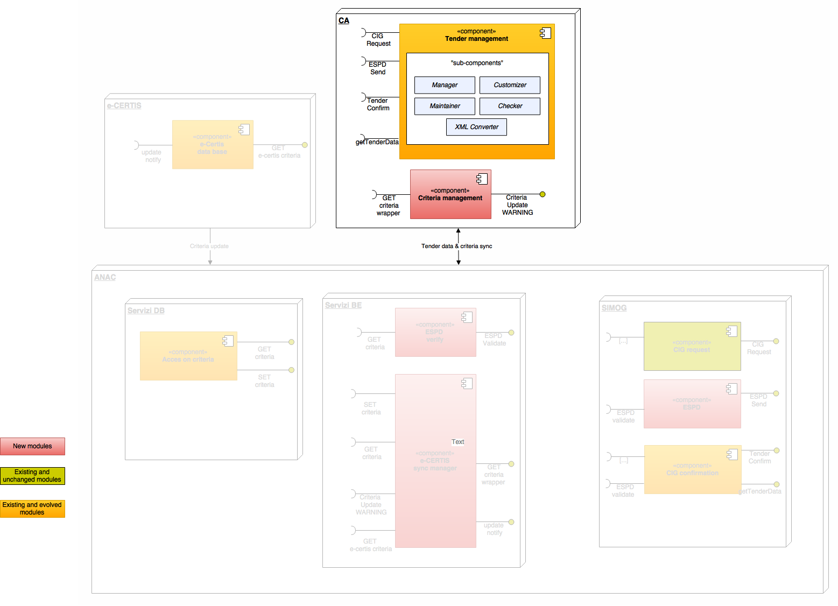

Figure 3 Focus on the components to be developed in SATER

Here below, a short description of each component:

*Manager*

It aims to control all the activities involving the use of the ESPD.

*Customizer*

It has the task of storing and managing all the possible customizations for each tender procedure and for each participant, also mapping each different role and authorization profile.

*Maintainer*

It carries out the activities needed to ensure at all times the perfect alignment between SATER platform and SIMOG of the data structures related to selection criteria and exclusion grounds.

*Checker*

Verify that all the constraints imposed by the different criteria are met and that the information is complete before converting the ESPD to a .pdf file for the acquisition of the digital signature.

*XML Converter*

It transposes to the target XML format both the ESPD created by the CA and the ESPD responses filled-in by the EOs. This task is done bidirectionally, that is, it works either in upload or in download. In particular, the system wil enable the end-user to:

* upload an ESPD response produced in XML format through any other tool;
* extract an ESPD response or request in XML format for processing in other platforms or with other tools.

**The new process flow**

The typical tendering process currently followed in Italy is based on a manual association of the CIG codes to the lots and does not foresee an automated validation in SIMOG of the selection / exclusion criteria proposed by the CA in the ESPD request.

With the new scenario described in this document, many automated steps will be introduced, bringing a general simplification in operational tasks and ensuring consistency to the overall process.

The sequence diagram presented below intends to provide a schematic overview of the new tender process, with a specific focus on the core stages of ESPD request / response creation and validation:

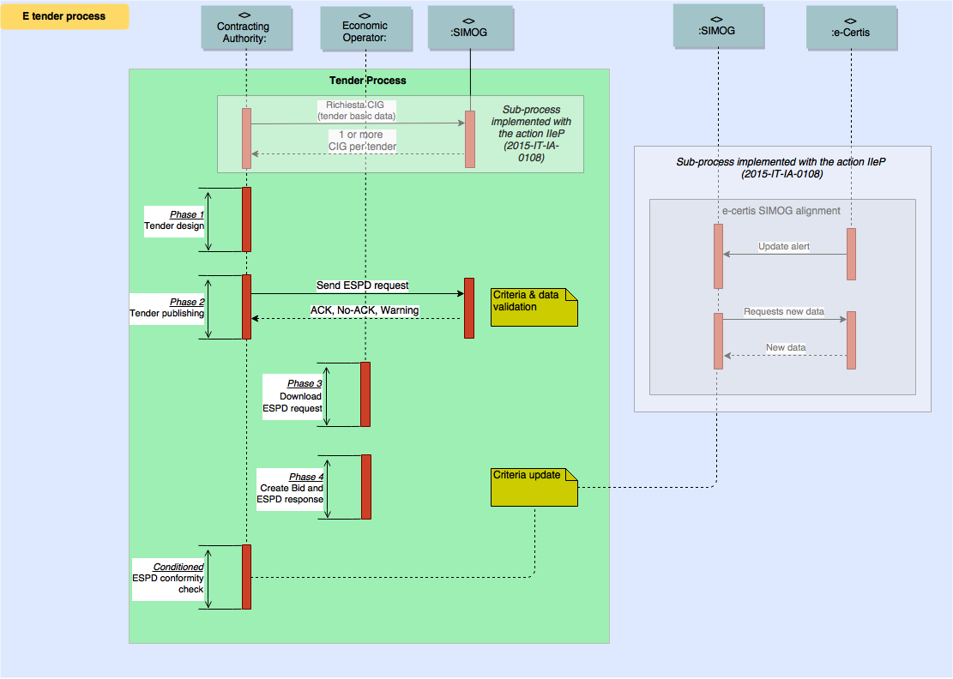

Figure 4 Sequence diagram of the new tender process, with focus on ESPD

# Gap analysis

With reference to the sequence diagram presented in the previous chapter, we provide in this section a short description of each tender phase in the target scenario (To Be model), together with a description of the gap identified in the As Is analysis and a brief explanation of the functional / technical intervention needed to bridge this gap.

Note: for further details on the solutions mentioned in the table below (Gap to As Is column), please refer to the following chapters 6 and 7.

| **To Be Scenario** | **Gap to As Is and proposed solution** |
| --- | --- |
| **Phase 1 – Tender design**  Responsible structures of the CA will enter in the SATER platform all the information necessary for the preparation of the tender, including those relating to the ESPD request to be linked. Once this stage is completed successfully, the tender is ready to be "Published" on the SATER Portal | Through the Customizer, Manager and Checker components, the current functions of SATER will be enhanced to allow the creation of an ESPD request. In particular:   * The ESPD request will be customized for the specific tender through the Customizer component; * The information to be filled by the CA in the ESPD request will be defined and controlled by the Manager component; * The ESPD request structure and data filled will be finally verified by the Checker component.   Interaction with A.N.AC. to obtain the ACK on the ESPD structure – in terms of completeness and validity of the selection criteria / exclusion grounds chosen - is described in the Gap Analysis document of the *IIeP action* (2015-IT-IA-0108). |
| **Phase 2 – Tender publishing**  At this stage, all the controls necessary for the publication of the tender are made. By way of example and not intended to be exhaustive:   * Consistency of the information with respect to the model foreseen for the tender; * Presence and correctness of all the dates envisaged in the process (eg start / end date for submitting bids, end date for presenting questions, date of first public session, ...); * Final validation of the ESPD request with both internal information and requirements expressed / maintained by the national tender monitoring system (SIMOG, run by with A.N.AC.).   If all the controls are successful, the tender is published and the XML-formatted version of the ESPD request is automatically included among other tender documents in order to allow the interested / invited EOs to fill-in the ESPD response on other platforms or with other external tools. | As soon as the CA’s responsible user requests the publication of the tender, the following steps are taken, in addition to all the controls already present on SATER platform:   * Verify the ESPD request through the Internal Checker component activated on the platform; * Send the ESPD request to SIMOG for verification and subsequent publication of the tender on A.N.AC. system; * Publish the ESPD request in tender documentation to allow anyone to use it to compile corresponding ESPD response outside SATER platform.   Note: as described in next phase 4, SATER platform will be enhanced with an embedded tool to support the EO in filling in and validating an ESPD response. |
| **Phase 3 – Download ESPD request**  If the Economic Operator considers it useful and appropriate, the ESPD request can be downloaded from both its private area (available for all registered users) and the institutional public space of Intercent-ER (PLONE). Once downloaded, the ESPD request is suitable to be uploaded in all the external tools and platforms compliant with ESPD standard form. There, the EO can compile and download an ESPD response, which can be used to prepare a bid on SATER platform (see next step). | No Updates - In the public area (PLONE) and in the reserved area for registered users, today it is already possible to download all the documents entered by the RUP as "Tender documents" (*Atti di Gara*) . Since the ESPD request is automatically added as an XML document to this virtual repository, the Economic Operator is able to download it with no additional effort. |
| **Phase 4 – Create bid and ESPD response**  At this stage, Economic Operators can choose to include, within their bid, the ESPD response. The possible choices are:   * *Complete the ESPD response directly in SATER platform*:   It is the easiest way to enter all the information you need through a tool on the platform, which controls what is edited and "precompletes" all the parts for which it already has information (eg. EO master data);   * *Use an ESPD response previously compiled on SATER platform*:   The SATER platform provides the EO with all the previously compiled ESPDs and allows to retrieve from them all the responses compatible with the ESPD request foreseen for the specific tender. Of course, it is necessary to check the consistency and correctness of the responses entered automatically and, if necessary, to supplement the information requested and not present in the selected ESPD.   * *Upload to SATER platform an ESPD response compiled in a different platform or with an external tool*:   For this case, the same considerations apply as in the previous one (see point above). In fact, there is no certainty about the quality and completeness of the information included in the uploaded ESPD response.  All the operations listed above can be carried out during the various stages of the preparation of the bid by all the parties involved in – and authorized to - the preparation of the proposal in response to the tender | In the administrative envelope management, the system will provide the authorized user with all the features needed to manage ESPDs both for the main company and for other companies participating in the bid with other roles. The components involved are ESPD Manager, ESPD Checker, and ESPD XML Converter. Through the Manager component, all data-entry activities are managed within SATER platform; the ESPD Checker performs all the controls on document data, whether they are inserted directly into the platform or uploaded by means of XML files coming from outside; Finally, DGUE XML Converter gives the EO the ability to transform what comes from external systems in the internal management format accepted by the platform.  A specific feature will be implemented to allow the end user to download the ESPD response in a format (XML) suitable for reuse in other technical environments. |
| **Conditional step - Criteria update from Simog to SATER Platform**  The platform, with a frequency to be defined, invokes SIMOG services to determine whether any changes have taken place with reference to the criteria registered in e-Certis and retrieved by the national A.N.AC. system. If so, a verification process of their possible use in the tenders is started and subsequent notification is sent to the responsible users who are in charge to make the necessary adjustments to “conform” again the ESPD schema to the rules defined. | On SATER platform, available 24x7, there will be a service – executed with a daily frequency - that constantly queries the A.N.AC. system to check if there are any changes to the quantity and quality of the criteria recorded on it. If so, in addition to updating the criteria description tables, the system also checks the presence of unpublished tenders that make use of changed criteria, in order to ensure a strict compliance with A.N.AC. guidelines. In the latter case, a notification is sent to the user in charge of the tender in order to inform him of the action and give him the opportunity to take the appropriate corrective action. |

Table 1 Tender process steps - Gap analysis

# Data Model Design

AAAAAA

# Integration Services Design

AAAAAA